**Project**

Creating replica set. 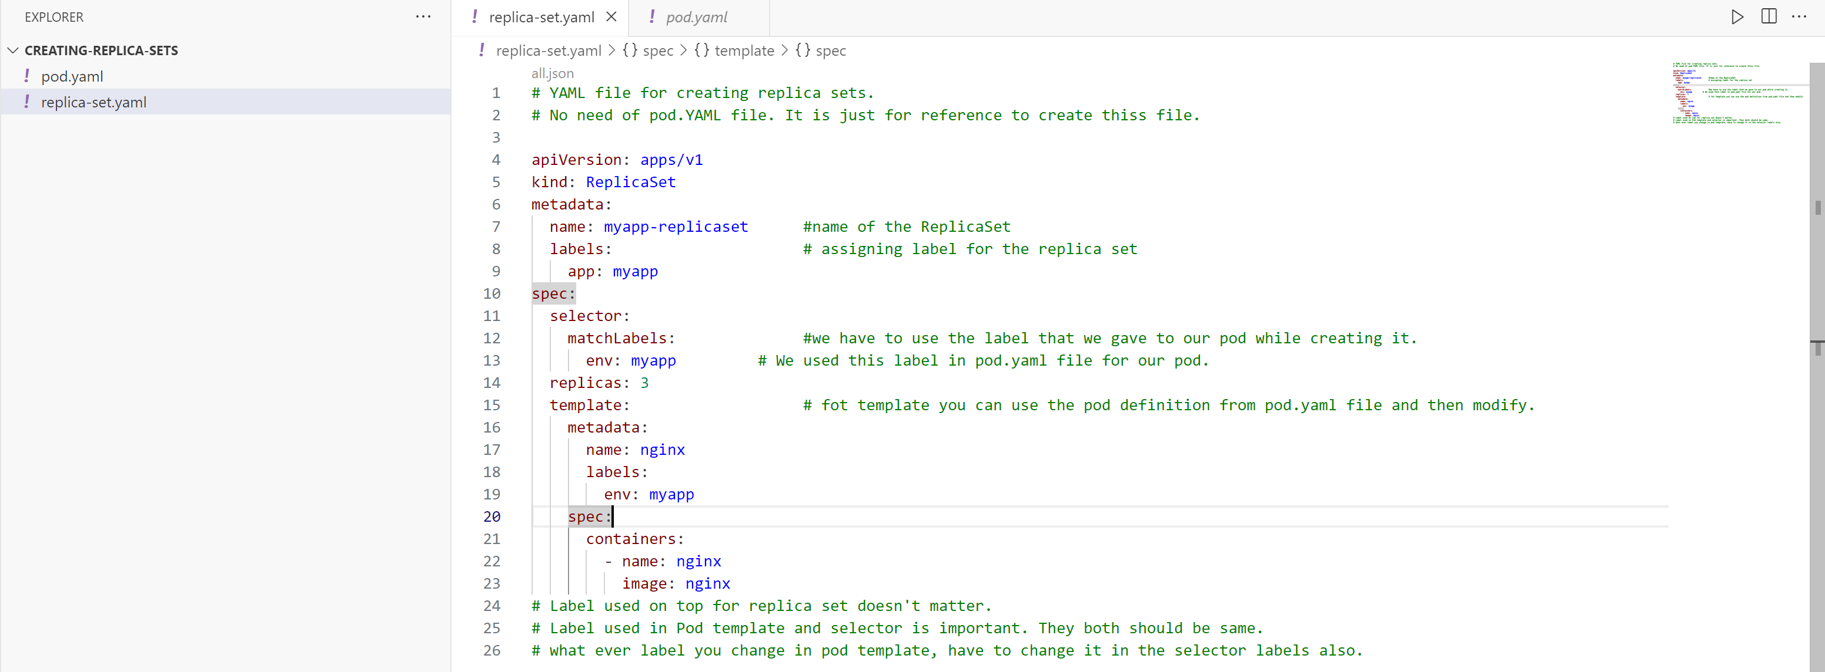

Check the status: 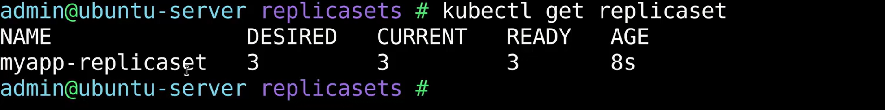Status of pods: 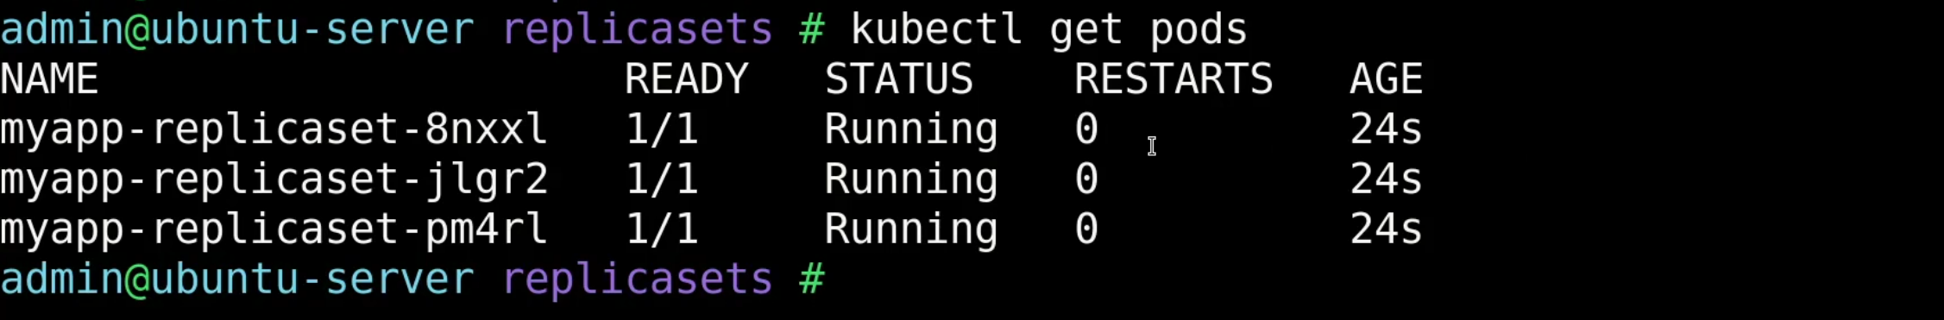Name of the pod begins with a replica set. Let’s try to delete one of thee pods.

Copy one of the pod names from above command. and executre delete command.

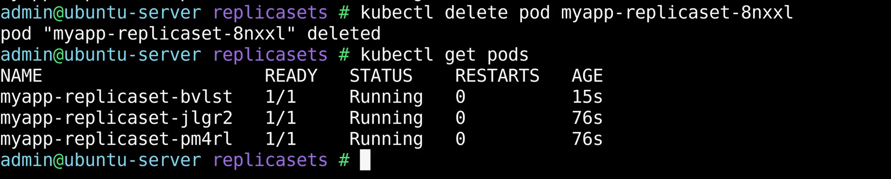But still we can see three pods. It deleted the pod. But replicas set managed to create a new pod as it ordered to maintain 3 replicas all the time.

Command: To describe replica set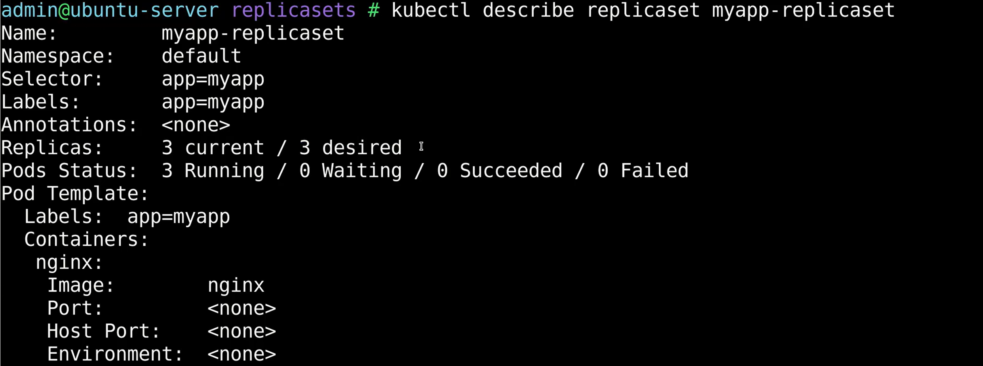Here we can also see value of how many replicas is needed, name of replica set, lable of it, pod template, events occurred during this replica set.

**What if we try to create more pods than required?**

Lets try to create a new pod using pod-definition file and give same label for this pod that you gave in the previous example under pod definition template in replica set YAML file. 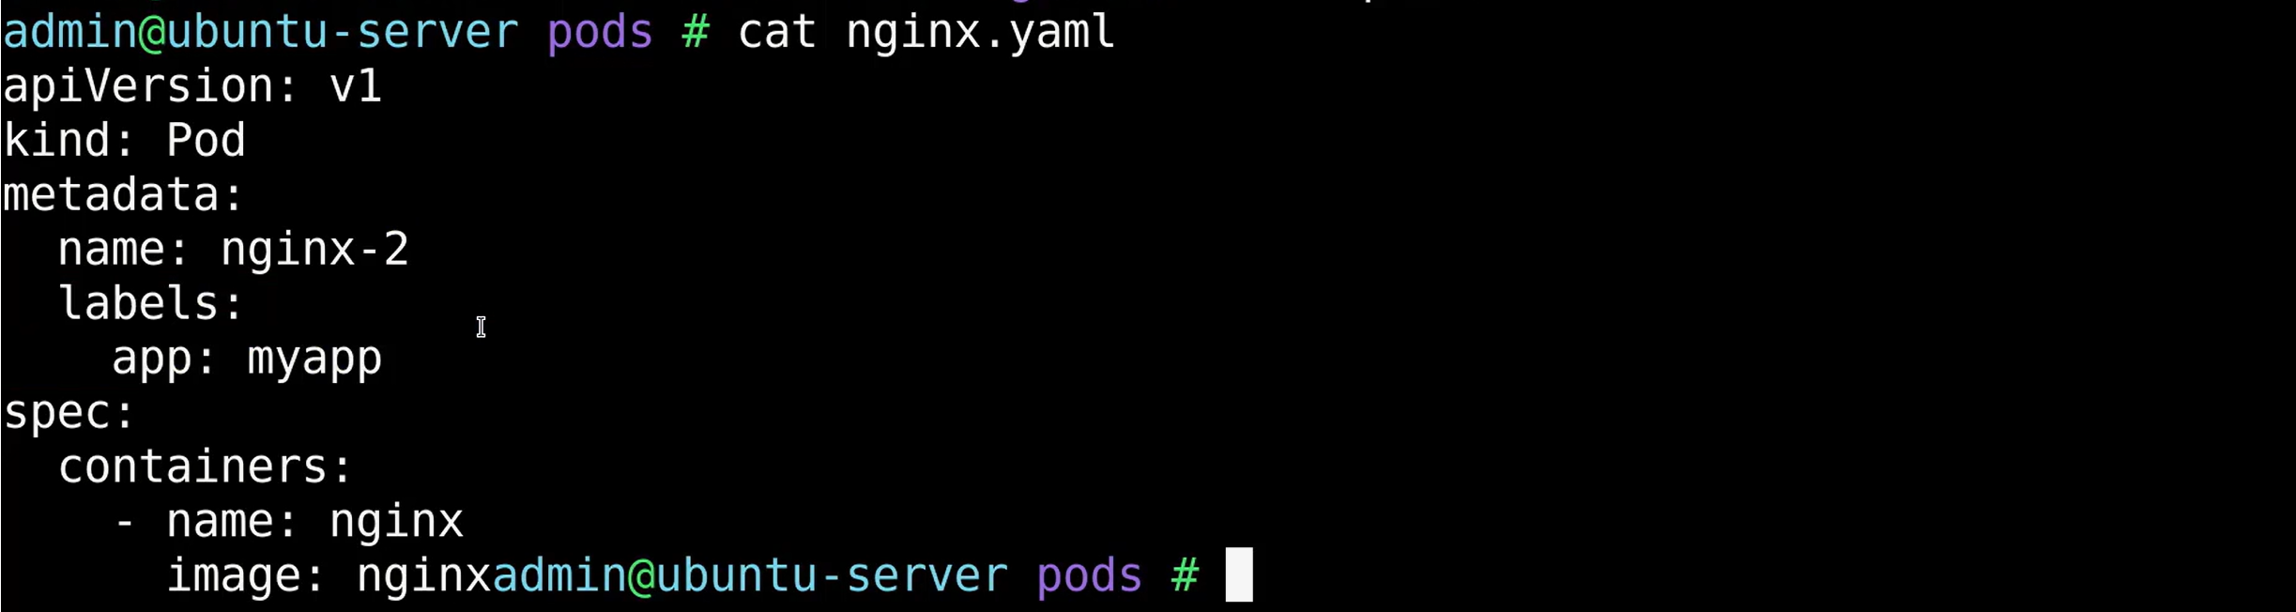Checking current pods list: 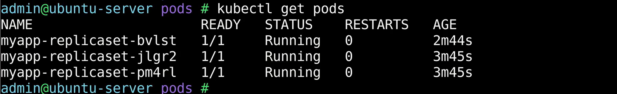Now try to create a pod using the pod definition file. Here in this case it is nginx.yaml file.  Now, check the newly created pod status. It will be in terminating.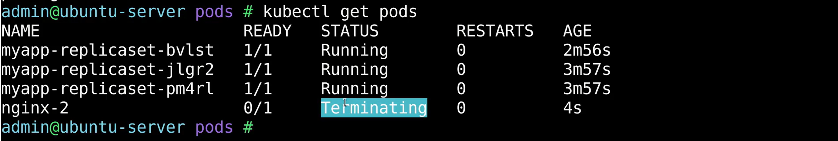

It will not allow, to create more pods using same labels than the number of replicas configured on the replica set. 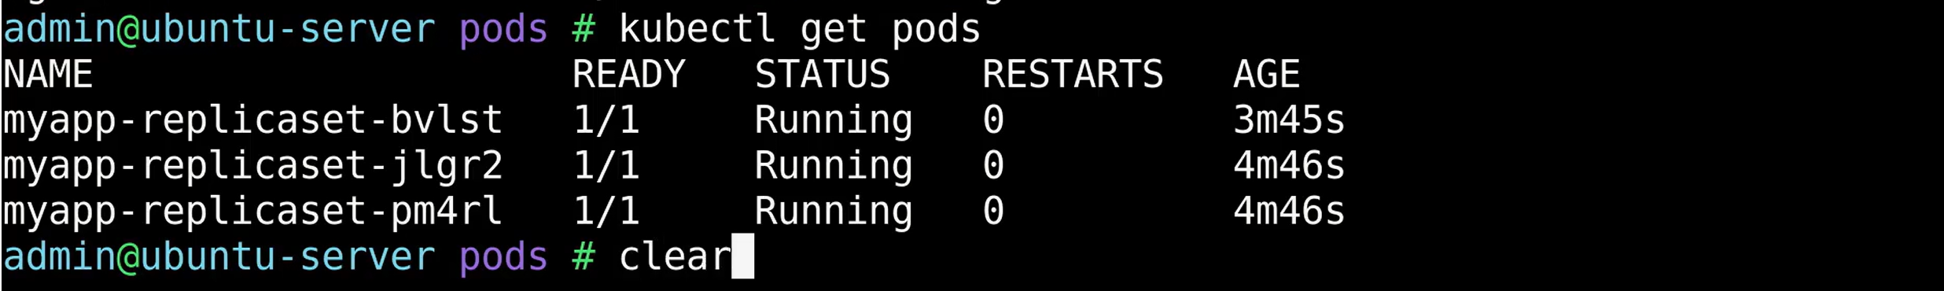**How to update replica set?**

We are trying to scale up our application and we have to update the replicas count to 4 or 5. This you do with this below command: It opens a temporary file in Vim editor, created K8s in memory. It is not opening originla file. 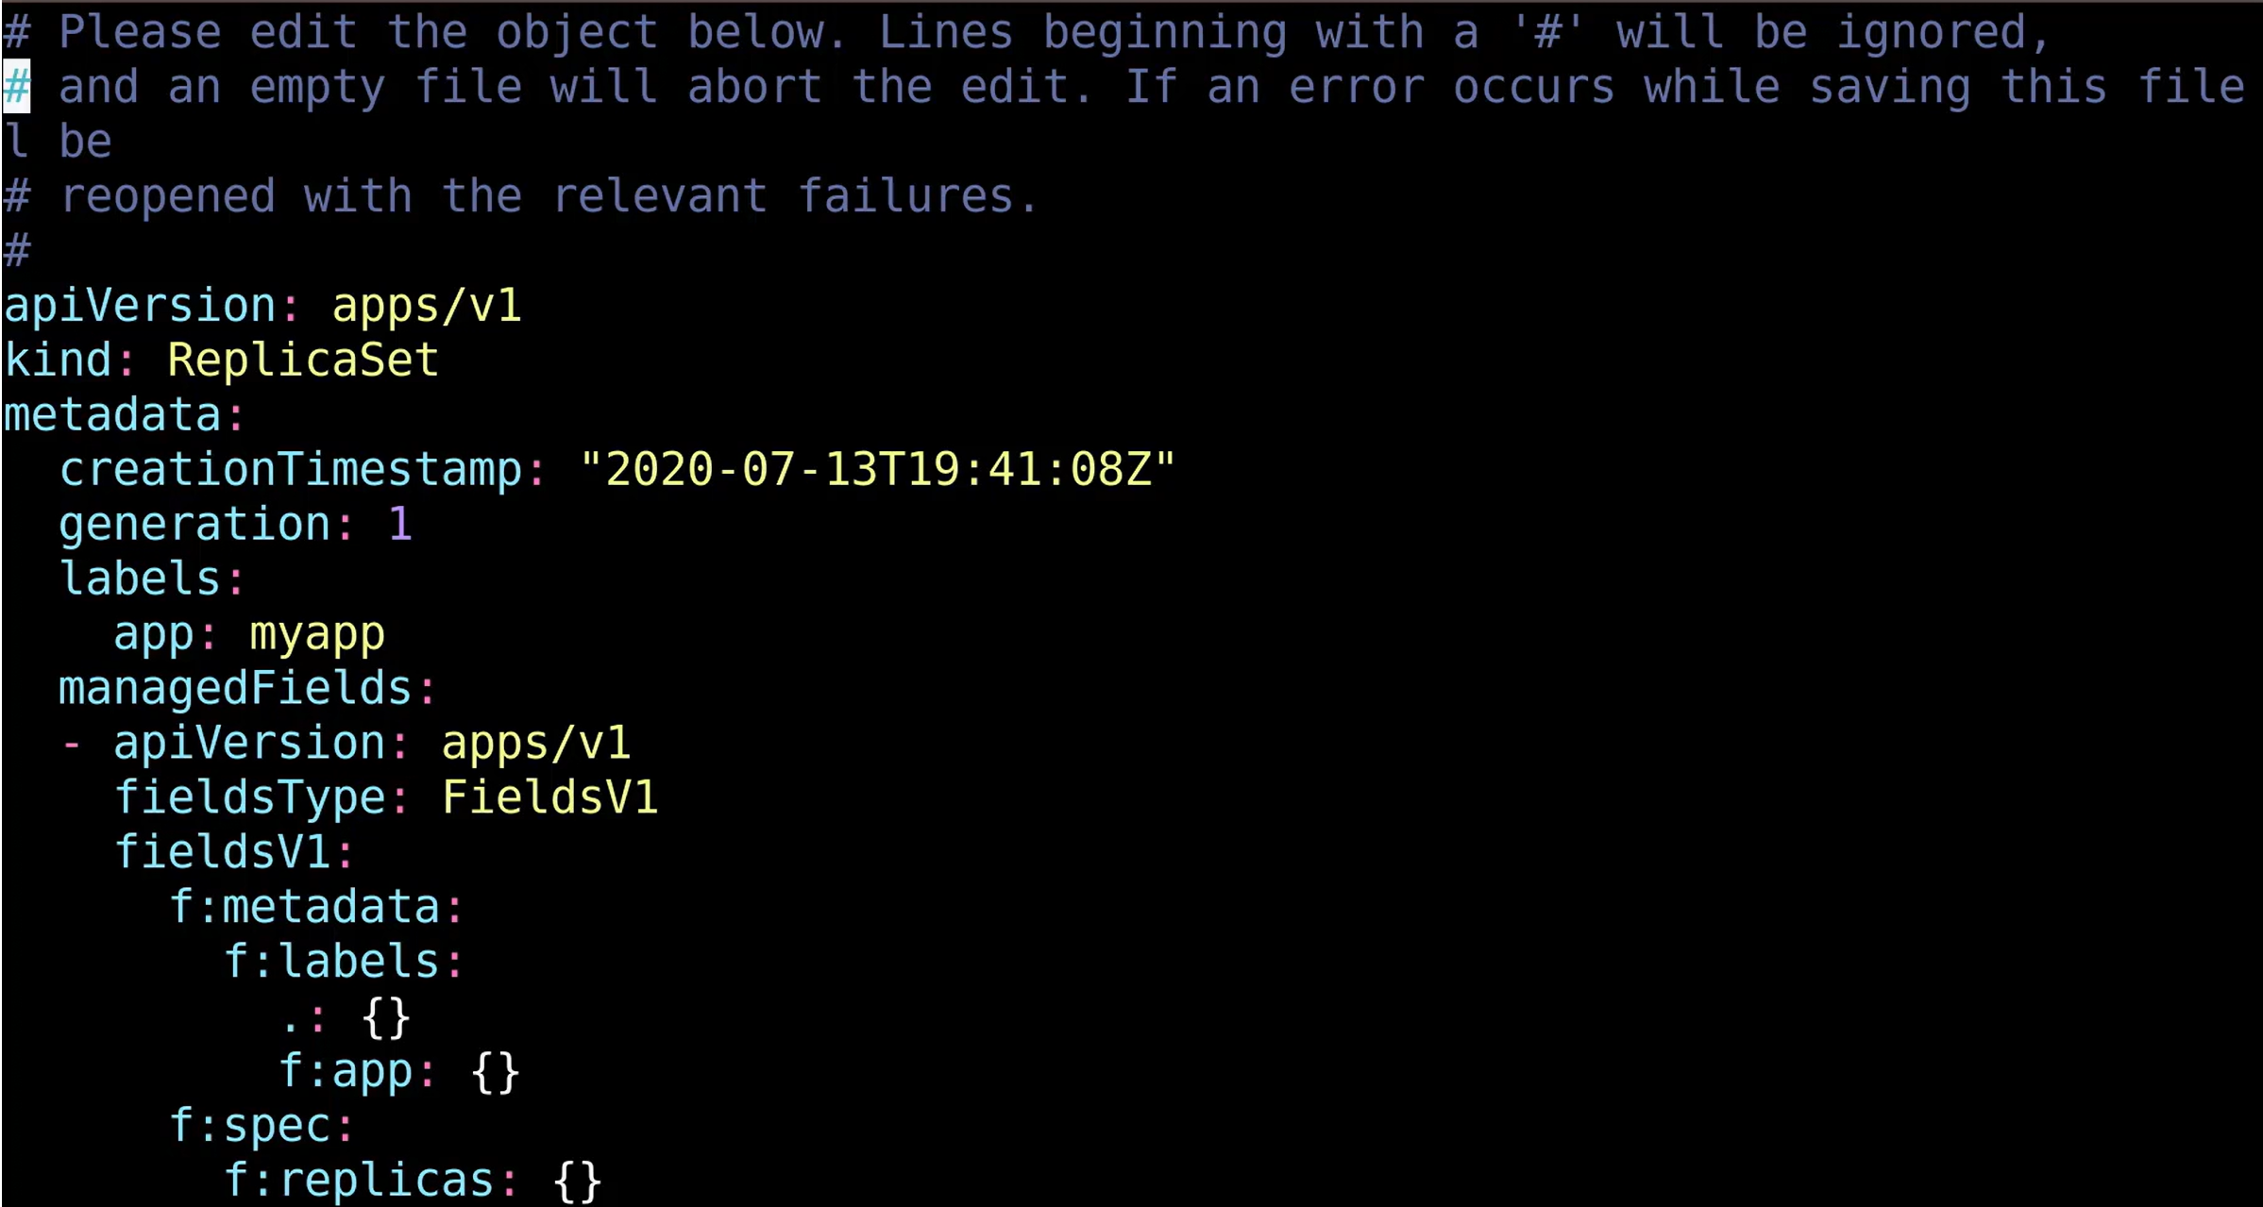The changes made to this file will be directly applied on the running configuration on the cluster as soon as the file is saved. Make sure about the changes you are doing. Scroll to the last and change the replicas to 4 and save it.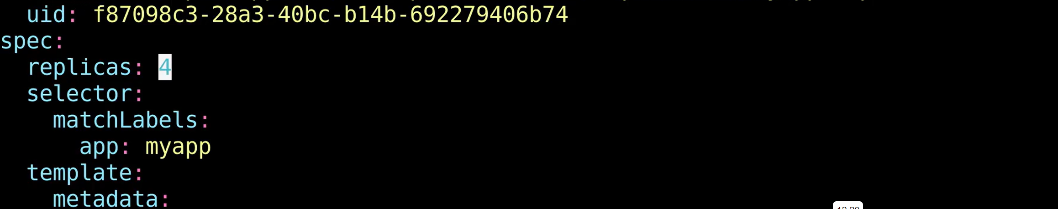New pod is cretaed 6 seconds back. 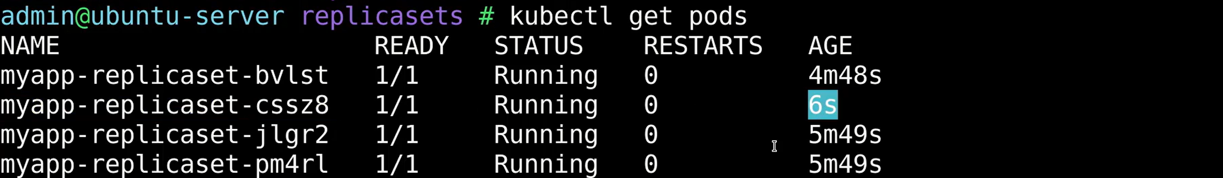**Scale Down:** Instead you can scale the replica set directly from kubectl CLI. Now, see two pods will be terminated.

